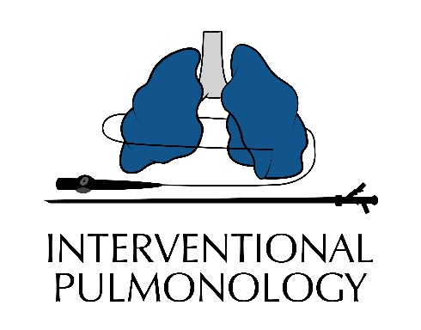

**Capping**

For capping trials do not use the white tip inner cannula.

Please continue being active while capping.

* Cap for 1 hour per day for 4 days
* Cap for 2 hours per day for 4 days
* Cap for 4 hours per day for 4 days
* Cap for 8 hours per day for 4 days
* Cap for 16 hours per day

**Do not cap when sleeping**

When complete first day of 16 hours, contact the Interventional Pulmonology office.

313-916-3650